***RDBMS LAB PACKAGE***

**ABSTRACT:**

This project focuses on creating a relational database schema tailored for a music streaming platform, supporting core functionalities like user account management, music library organization, and user engagement features. The schema includes tables for Users, Artists, Albums, Tracks, and Playlists, each with well-defined relationships to enable efficient data retrieval and manipulation. Many-to-many relationships, such as those between Playlists and Tracks, or Users and Artists (followers), are handled through dedicated join tables (e.g., Playlist_Tracks, Followers, Likes), allowing users to curate playlists, like tracks, and follow favorite artists. The schema is designed with referential integrity and cascading deletions to maintain data consistency, enabling a scalable foundation for a seamless and interactive user experience in a streaming environment.

**TEAM DETAILS:**

1. **Nagyd M A (23pw13)**
2. **Raghul Pranesh K V (23pw22)**

**ER DIAGRAM:**

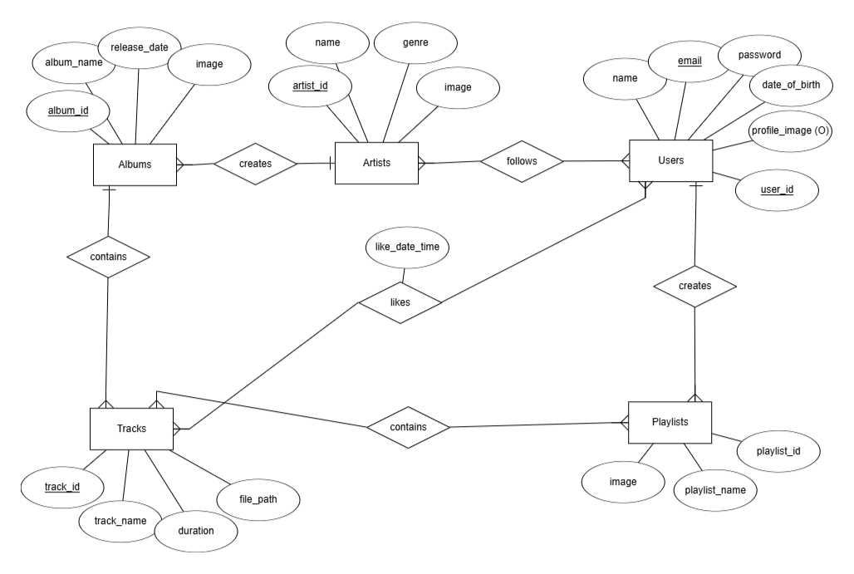

**Relation Schema:**

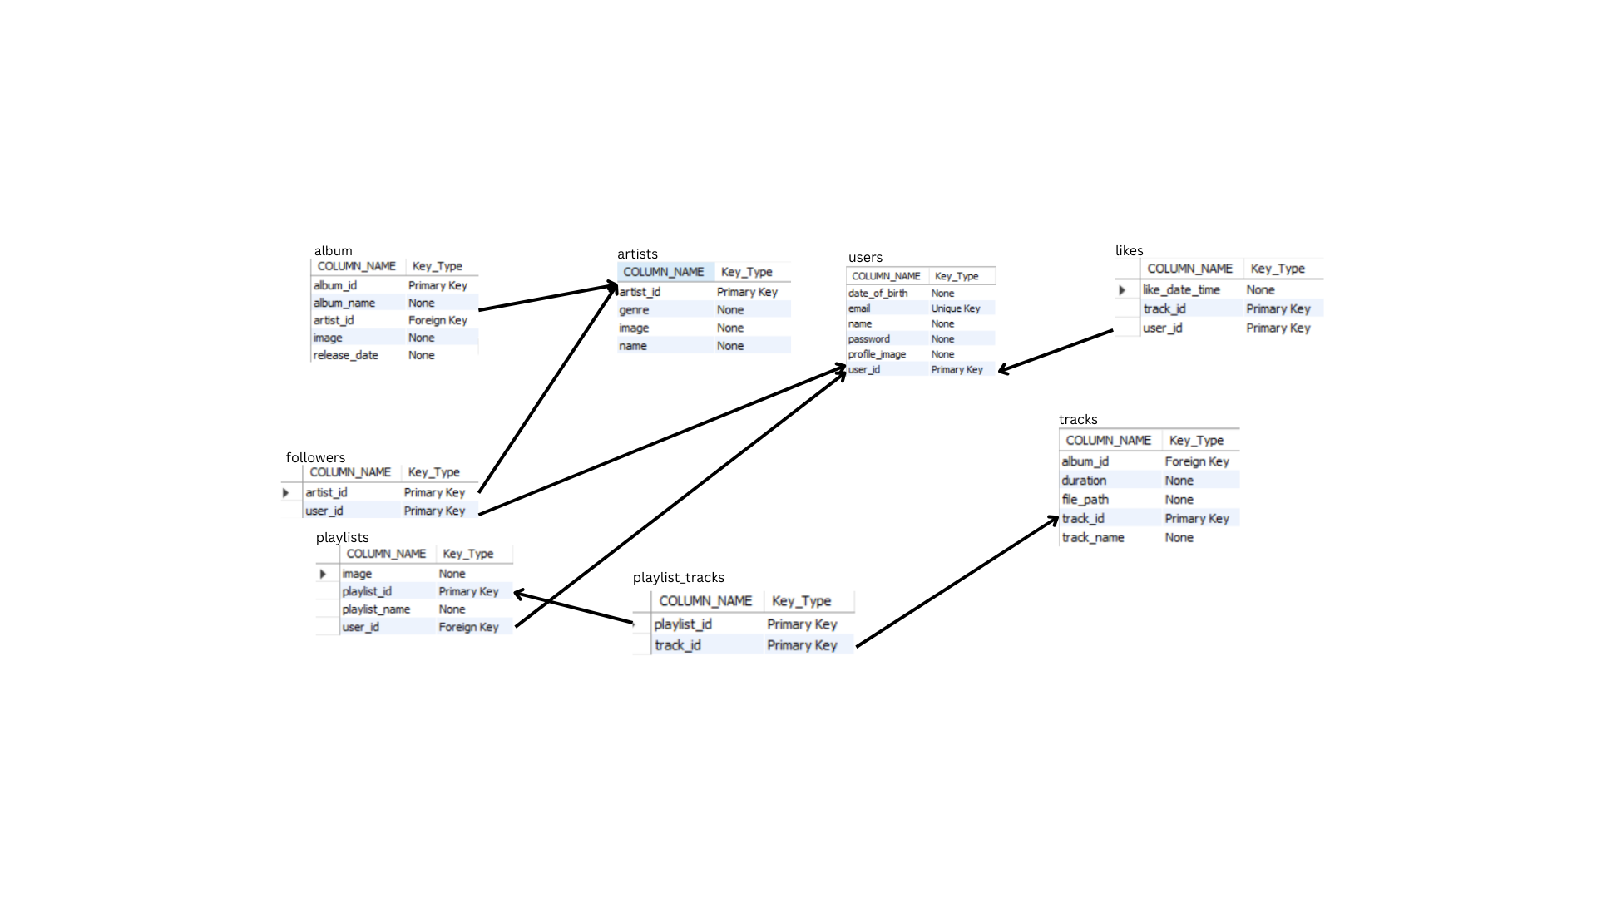

**Screenshots:**

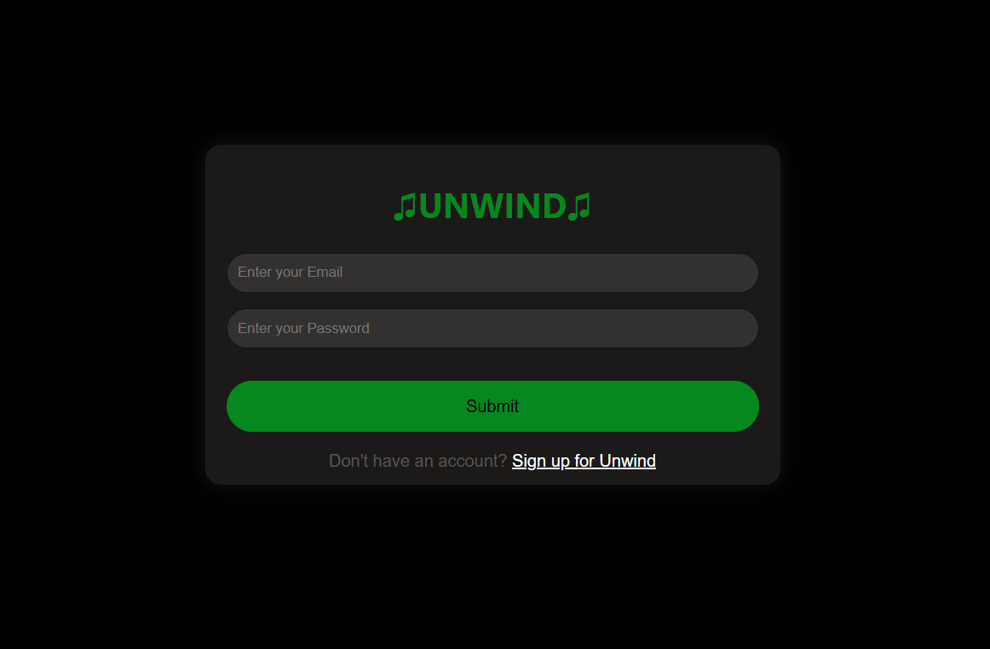

**Login page.**

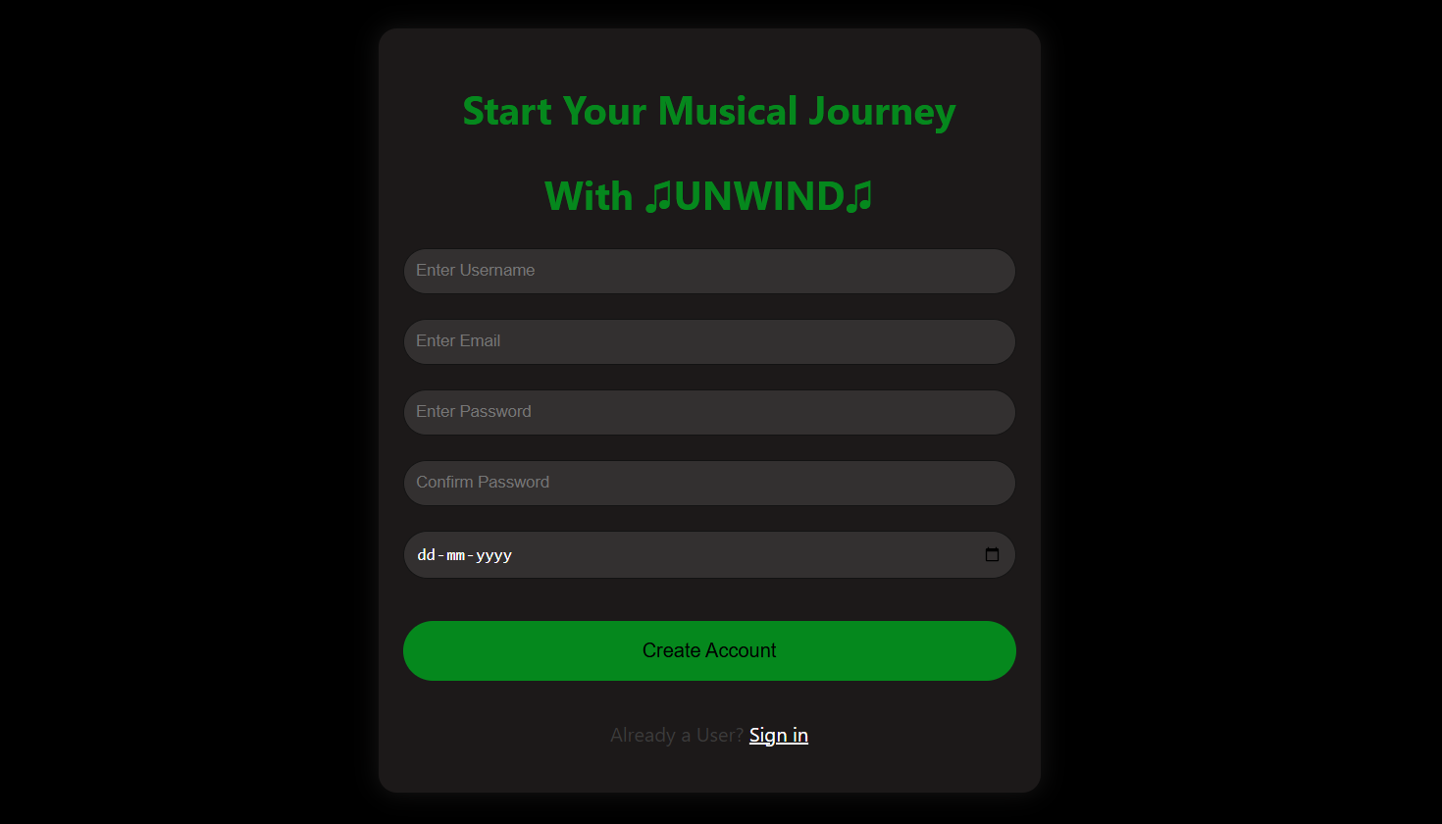

**Sign up page.**

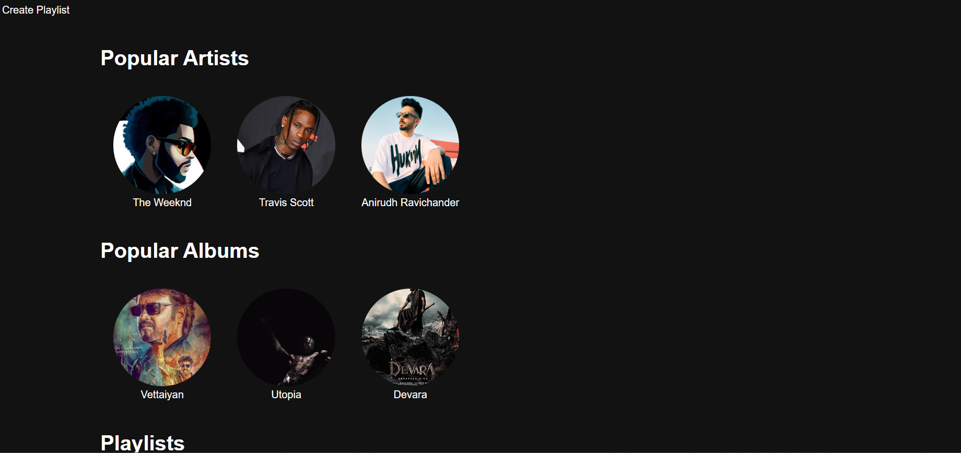

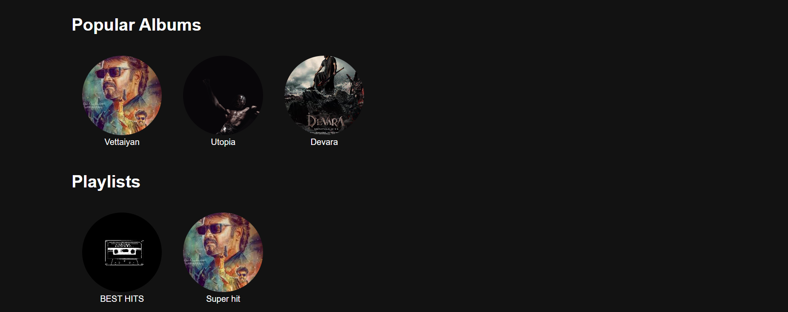

**Home page.**

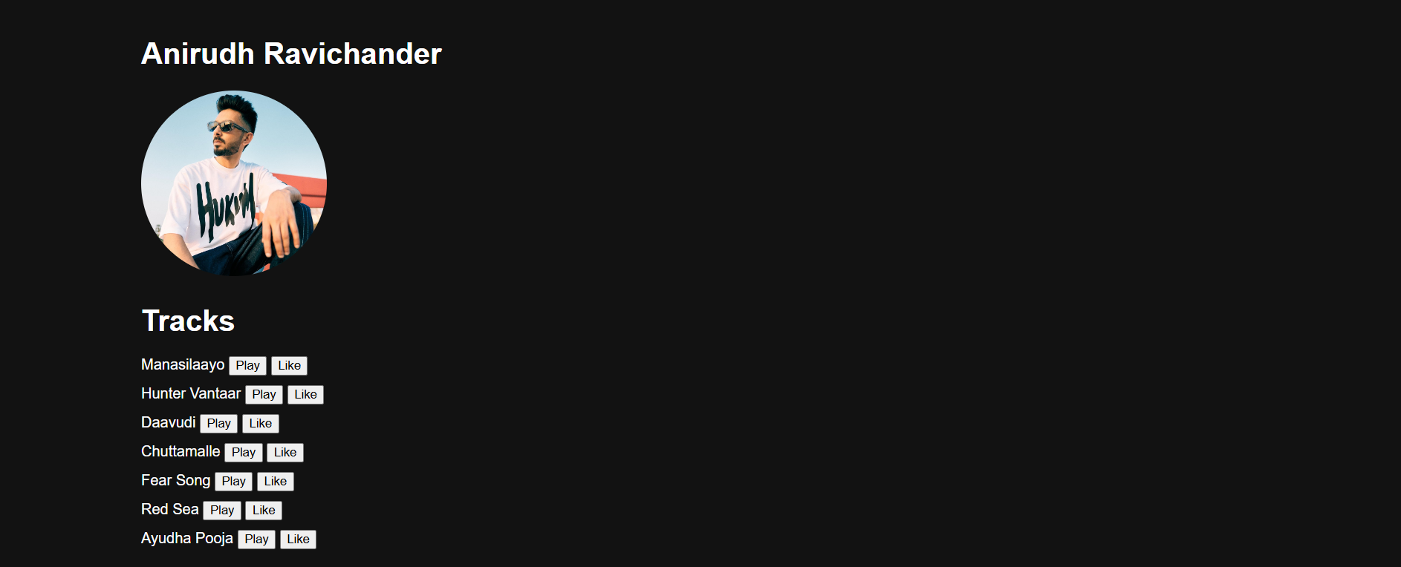

**When artists is clicked his songs are displayed.**

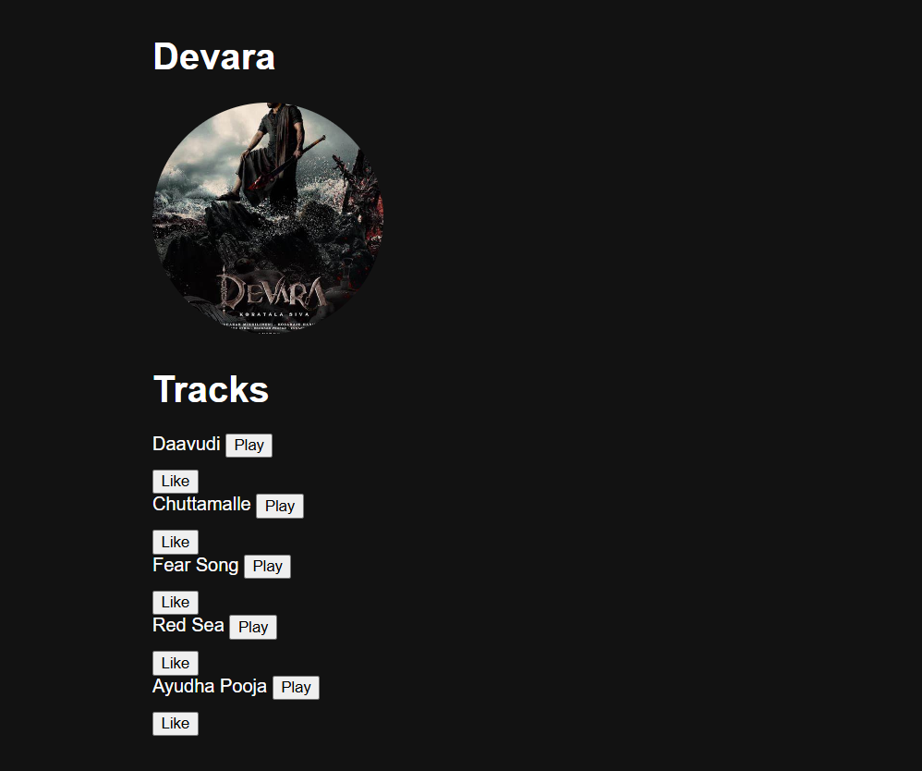

**When album is clicked its songs are displayed.**

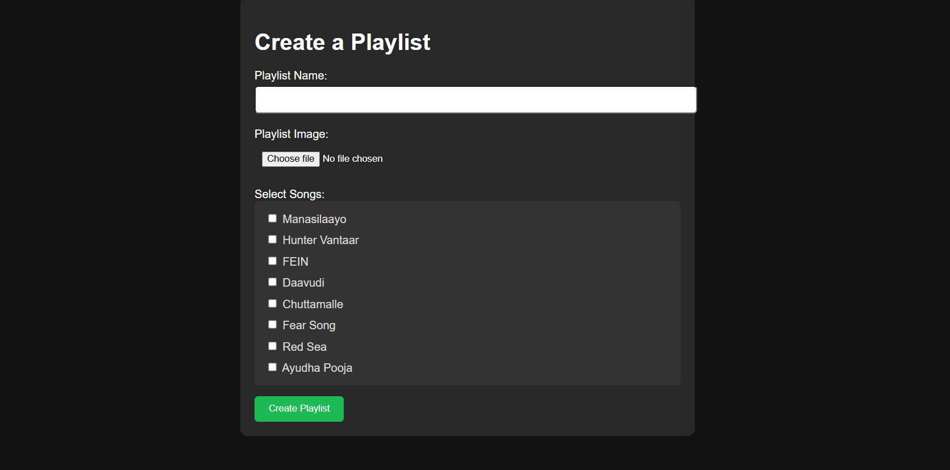**Create playlist.**